 | 26.14.1 Editors - Properties Editor - Object Data Properties Tab - Mesh Object
Table of content
Detailed table of content 1
Vertex groups panel 4
Shape Keys panel 7
UV Maps panel 11
Color Attributes panel 12
Face Maps panel 14
Attributes panel 15
Normals panel 16
Texture Space panel 17
Remesh Panel 18
Geometry Data panel 19
Custom Properties Panel 19

Detailed table of content
Detailed table of content
Detailed table of content 1
Vertex groups panel 4
Active Vertex Group list 4
Group name 4
Lock 4
Drag Handler 4
Search Field 5
Invert 5
Sort by Name 5
Add + 5
Remove - 5
Specials menu 5
Sort by Name 5
Sort by Bone Hierarchy 5
Copy Vertex Group 5
Copy Vertex Groups to Linked 5
Copy Vertex Group to Selected 5
Mirror Vertex Group 5
Mirror Vertex Group (Topology) 6
Remove from All Groups 6
Clear Active Group 6
Delete All Unlocked Groups 6
Delete All Groups 6
Lock All 6
Unlock All 6
Lock Invert All 6
Move Vertex Group Up / Down 6
Assign 6
Remove 6
Select 6
Deselect 7
Weight 7
Set Active Group 7
Shape Keys panel 7
Workflow 7
Active Shape Key Index 8
Shape Key name 8
Slider value 8
Lock 8
Drag Handler 8
Search Field 8
Invert 9
Sort by Name 9
Add + 9
Remove - 9
Specials menu 9
New Shape From Mix 9
Mirror Shape Key 9
Mirror Shape Key (Topology) 9
Join as Shapes (Transfer Mix) 9
Transfer Shape Key 9
Delete all Shape Keys 9
Move to Top 10
Move to Bottom 10
Move Shape Key Up / Down 10
Relative 10
Relative 10
Shape Key Lock (pin icon) 10
Shape Key Edit Mode (edit mode icon) 10
Value 10
Range 10
Vertex Group 10
Relative To 10
Absolute 10
Shape Key Lock (pin icon) 10
Shape Key Edit Mode (edit mode icon) 11
Re-Time Shape Keys (clock icon) 11
Interpolation 11
Evaluation Time 11
UV Maps panel 11
UV Map 11
Workflow 11
Active UV Loop Key Index 11
UV Map name 11
Active Render 12
Drag Handler 12
Search Field 12
Invert 12
Sort by Name 12
Add + 12
Remove - 12
Color Attributes panel 12
Active Color Index 12
Color index name 12
Active Render 13
Drag Handler 13
Search Field 13
Invert 13
Sort by Name 13
Add + 13
Add Color Attribute Specials 13
Name 13
Domain 13
Data Type 13
Color 13
Ok 13
Remove - 14
Specials menu 14
Duplicate Color Attribute 14
Convert Color Attribute 14
Face Maps panel 14
Face Map Index 14
Face map name 14
Drag Handler 14
Search Field 14
Invert 14
Sort by Name 14
Add + 15
Remove - 15
Attributes panel 15
Attributes Index 15
Attribute name 15
Drag Handler 15
Search Field 15
Invert 15
Sort by Name 15
Add + 15
Remove - 16
Attribute Specials 16
Convert Attrribute 16
Mode 16
Domain 16
Data Type 16
Normals panel 16
Autosmooth 16
Autosmooth angle 16
Add / Clear Custom Split Normals Data 17
Texture Space panel 17
Texture Mesh 17
Auto Texture Space 17
Location, Size 18
Remesh Panel 18
Mode 18
Voxel Size 18
Adaptivity 18
Fix Poles 18
Smooth Normals 18
Preserve 19
Volume 19
Paint Mask 19
Face Sets 19
Voxel Remesh / QuadriFlow Remesh 19
Geometry Data panel 19
Clear Sculpt-Mask Data 19
Clear Skin Data 19
Store Vertex Bevel Weight 19
Stores Edge Bevel Weight 19
Store Edge Crease 19
Custom Properties Panel 19
Add 20
Edit 20
Remove 20

Vertex groups panel

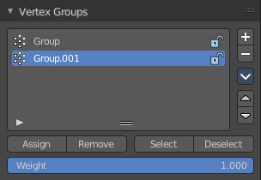
A Vertex group is a group of vertices, a selection of the mesh. It is for example used to weight a specific mesh part to a bone. Or to control the growth of hair particles.
This panel allows you to manage and edit vertex groups. Weight painting creates vertex groups automatically.
In Edit mode this panel shows some further controls.
Vertex groups exists for mesh and lattice objects.

Active Vertex Group list
A List of the vertex groups for this mesh.

Group name
The name of the group. It can be renamed by double clicking at it.

Lock
The lock icon at the end of a group name locks the group from being editable.

Drag Handler
The two vertical lines at the end is a handler with which you can expand the list.

Search Field

You can expand a search field at the bottom of the list. Type in your term and hit enter to filter for your term.

Invert
Exclude the search term instead of searching for it.

Sort by Name
Sort the List by name.

Add +
Create an empty vertex group.

Remove -
Deletes the active vertex group.

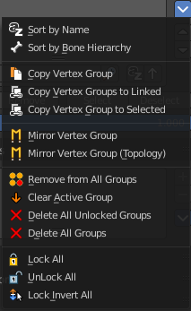
Specials menu

Sort by Name
Sorts the vertex groups alphabetically by name.

Sort by Bone Hierarchy
Sorts the vertex groups by the hierarchy of the assigned bones.

Copy Vertex Group
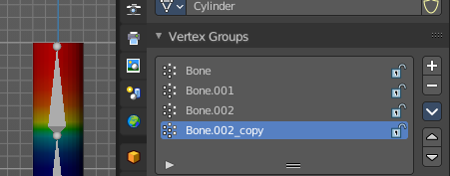
Add a copy of the active vertex group as a new group. The new group will be named like the original group with “_copy” appended at the end of its name. And it will contain associations to exactly the same vertices with the exact same weights as in the source vertex group.

Copy Vertex Groups to Linked
Copy vertex groups of this mesh to all linked objects which use the same mesh data (all users of the data).

Copy Vertex Group to Selected
Copy all vertex groups to other selected objects provided they have matching indices (typically this is true for copies of the mesh which are only deformed and not otherwise edited).

Mirror Vertex Group
Mirrors weights and/or flips group names from one side of a symmetrical mesh to the other.
Only mirroring along local X axis is supported. Vertices that have no corresponding vertex on the other side will not be affected. Note, the weights are not transferred to the corresponding opposite bone weight group.

Mirror Vertex Group (Topology)
Performs the Mirror Vertex Group with the Topology Mirror option enabled.

Remove from All Groups
Unassigns the selected vertices from all groups. Even locked.

Clear Active Group
Remove all assigned vertices from the active group. The group is made empty. Note that the vertices may still be assigned to other vertex groups of the object. This feature does not affect locked groups.

Delete All Unlocked Groups
Remove all vertex groups from the object that are not locked.

Delete All Groups
Remove all vertex groups from the object.

Lock All
Lock all groups.

Unlock All
Unlock all groups.

Lock Invert All
Invert group locks.


Move Vertex Group Up / Down
Moves the selected vertex group up or down in the list.

Assign
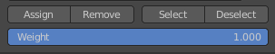
Assign the selected vertices to the active vertex group.

Remove
Remove the selected vertices from the active group.

Select
Select all vertices in the group.

Deselect
Deselect all vertices in the group.

Weight
The weight value that gets assigned to the selected vertices.

Set Active Group
Lets you select the group that will become the active one (menu only).

Shape Keys panel

This panel allows you to see and manage shape keys. A shape key is a vertex animation.
Shape keys are for example used for facial animations, when you don't want to use a face rig with bones. The idea is to model a shape key pose for smiling, one for laughing, one for sad, and so on. And then blend the shape key poses together as needed.
Shape keys are also called morph targets or blend shapes.

Workflow

In Object mode add a shape key. This first shape key is called Basis by default. It is the base for the vertex animation. This basis shape key is the base shape for all further shape keys. It cannot be modified or keyframed.
Now add a second shape key. This second shape key will have more controls so that you can modify it in the needed way.


Enter edit mode with this key 1 selected.
Modify the geometry by moving some vertices around.
Switch back to Object mode.


Have a look at the value slider. This slider defines how the key 1 shape key blends with the Basis shape key.
Move it from value 0 to value 1. You will notice that the vertices that you have modified in Key 1 will now start to move to a new position. Dependent of how strong the value is. With a value of 1 it will be at the position of how you modeled it.

To keyframe this shape click at the Animate property dot behind the slider. The slider will change its color. And the dot will change to a rhombus shape to indicate that there is a keyframe recorded at this frame.
Or you right click at the slider, and choose Insert Keyframe in the menu.
Move to another frame. Change the slider value, and set another keyframe.


Recorded keyframes can be found and further tweaked in the Dope sheet Editor in Shape Key Editor mode. Here you can also record further keyframes under Key / Insert Keyframes. And control the slider values from the channel list.

Add more shape keys and model and animate them as you need them.


Active Shape Key Index
A List of the shape keys for this mesh.
It contains two types of shape keys. Basis is the base shape. The other type relies at this shape as the base.

Shape Key name
The name of the shape key. It can be renamed by double clicking at it.

Slider value
The blend value of this shape key. The Basis shape key does not have such a slider.

Lock
The lock icon at the end of a group name locks the group from being editable.

Drag Handler
The two vertical lines at the end is a handler with which you can expand the list.

Search Field
You can expand a search field at the bottom of the list. Type in your term and hit enter to filter for your term.

Invert
Exclude the search term instead of searching for it.

Sort by Name
Sort the List by name.

Add +
Create a shape key.

Remove -
Delete the selected shape key.


Specials menu

New Shape From Mix
Add a new shape key with the current deformed shape of the object.

Mirror Shape Key
Mirror the shape keys on the X axis. This will not work if the mesh vertices is not fully symmetrical.

Mirror Shape Key (Topology)
Mirror the shape keys on the X axis. But detects the mirrored vertices based on the topology of the mesh. The mesh vertices do not have to be perfectly symmetrical for this action to work.

Join as Shapes (Transfer Mix)
Transfer the current resulting shape from a different object.
Select the object to copy, hold down Shift, then the object to copy into. Use this action and a new shape key will be added to the active object with the current mix of the first object.

Transfer Shape Key
Transfer the active shape key from a different object regardless of its current influence.
Select the object to copy, hold down Shift, then the object to copy into. Use this action and a new shape key will be added to the active object with the active shape of the first object.

Delete all Shape Keys
Delete all shape keys at this mesh.

Move to Top
Move the shape key to the top of the list. But not above the Basis shape key.

Move to Bottom
Move the shape key to the bottom of the list.

Move Shape Key Up / Down
Moves the selected shape key up or down in the list.

Relative
Set the shape keys to Relative or Absolute.


Relative
The shape is defined relative to the Basis or another specified shape key. And can be adjusted in its settings.

Shape Key Lock (pin icon)
Show the active shape in the 3D Viewport without blending. Shape Key Lock gets automatically enabled while the object is in Edit Mode.

Shape Key Edit Mode (edit mode icon)
If enabled, when entering Edit Mode the active shape key will not take maximum influence as is default. Instead, the current blend of shape keys will be visible and can be edited from that state.

Value
The weight of the blend between the shape key and its basis key. 0 means no influence, 1 full influence.

Range
Minimum and maximum range for the influence value of the active shape key.

Vertex Group
Limit the active shape key deformation to a vertex group.

Relative To
Select the shape key to deform from. It does not need to be the Basis shape key, but can also be another shape key.

Absolute

The shape changes over time, as defined in its settings.

Shape Key Lock (pin icon)
Show the active shape in the 3D Viewport without blending. Shape Key Lock gets automatically enabled while the object is in Edit Mode.

Shape Key Edit Mode (edit mode icon)
If enabled, when entering Edit Mode the active shape key will not take maximum influence as is default. Instead, the current blend of shape keys will be visible and can be edited from that state.

Re-Time Shape Keys (clock icon)
Absolute shape keys are timed, by order in the list, at a constant interval. This button resets the timing for the keys. Useful if keys were removed or re-ordered.


Interpolation
The interpolation method between shape keys.

Evaluation Time
Evaluate the shape key influence over the defined time. The evaluation starts at influence 0, and reaches 1 at the end of the value of this timer.

UV Maps panel

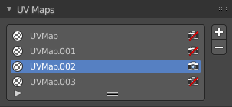
UV Map
A mesh object can have more than one UV map. Here you can manage the UV maps.
Just one UV map can be active at a time. But you can use secondary UV maps in a material.

Workflow
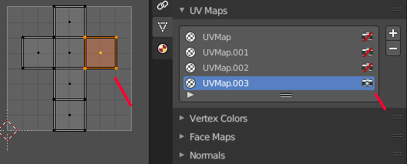
A UV map is simply a group of selected UV elements. So select an UV map, set it active by clicking at the Active Render symbol. And select the UV geometry that should be in this UV map.

Active UV Loop Key Index
A List of the UV maps for this mesh.
It contains two types of shape keys. Basis is the base shape. The other type relies at this shape as the base.

UV Map name
The name of the shape key. It can be renamed by double clicking at it.

Active Render
Set this UV map as the one to render. Just one UV map can be active at a time. But you can use secondary UV maps in a material.

Drag Handler
The two vertical lines at the end is a handler with which you can expand the list.

Search Field
You can expand a search field at the bottom of the list. Type in your term and hit enter to filter for your term.

Invert
Exclude the search term instead of searching for it.

Sort by Name
Sort the List by name.

Add +
Create a shape key.

Remove -
Delete the selected shape key.

Color Attributes panel

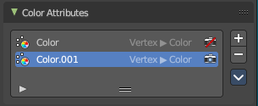
In vertex paint mode and sculpt mode you can paint vertices of a mesh with a color. This will create a vertex color index. You can see and manage this vertex color indexes in the Vertex Colors panel.
Vertex colors can for example be used to mix shaders together. Or also directly render them. In the shader editor color attributes can be used by the Attribute node.
A mesh can have more than one vertex color index and type. But just one index can be the active one.

Active Color Index
A List of the vertex color indexes for this mesh.

Color index name
The name of the vertex color index. It can be renamed by double clicking at it.

Active Render
Set this vertex color index as the one to render. Just one vertex color index can be active at a time. But you can use another vertex color index in a material.

Drag Handler
The two vertical lines at the end is a handler with which you can expand the list.

Search Field
You can expand a search field at the bottom of the list. Type in your term and hit enter to filter for your term.

Invert
Exclude the search term instead of searching for it.

Sort by Name
Sort the List by name.

Add +
Create a vertex color index.

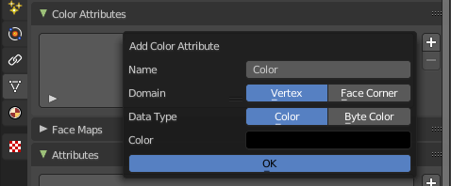
Add Color Attribute Specials

Name
The name of the color attribute index.

Domain
The domain of the color attribute.
- Vertex stores the color attribute data in the vertices of the mesh data
- Face Corner stores the color attribute data in the face corners of the mesh data

Data Type
The the color attribute type.
- Color stores RGBA color 32-bit floating point values
- Byte Color stores RGBA color 32-bit positive integer values

Color
The Default fill colour

Ok
Confirm to apply

Remove -
Delete the selected vertex color index.

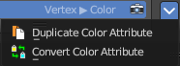
Specials menu

Duplicate Color Attribute
Duplicates the selected color attribute

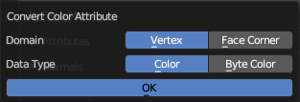
Convert Color Attribute
Convert a color attribute domain and data type. This tool calls a popup where you can choose what to convert.

Face Maps panel

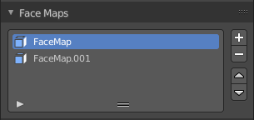
Face Maps creates custom gizmos to deform meshes by assigning faces to Face Maps. Face Maps can be used to rig in Object Mode and without making complicated rigging setups.
Face Maps is an experimental implementation. They are currently not fully implemented, and require add-ons to take full advantage of this feature.

Face Map Index
A List of the face maps for this mesh.

Face map name
The name of the face maps. It can be renamed by double clicking at it.

Drag Handler
The two vertical lines at the end is a handler with which you can expand the list.

Search Field
You can expand a search field at the bottom of the list. Type in your term and hit enter to filter for your term.

Invert
Exclude the search term instead of searching for it.

Sort by Name
Sort the List by name.

Add +
Create a face map.

Remove -
Delete the selected face map.

Attributes panel
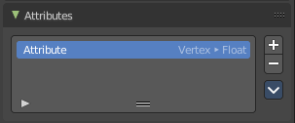
A list of the attributes at this object. Attributes can be used to identify an object in the shader editor or the geometry nodes editor

Attributes Index
A List of the attributes for this mesh.

Attribute name
The name of the attributes. It can be renamed by double clicking at it.

Drag Handler
The two vertical lines at the end is a handler with which you can expand the list.

Search Field
You can expand a search field at the bottom of the list. Type in your term and hit enter to filter for your term.

Invert
Exclude the search term instead of searching for it.

Sort by Name
Sort the List by name.

Add +
Create a new attribute.

Remove -
Delete the selected attribute.

Attribute Specials

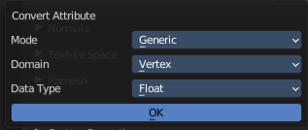
Convert Attrribute
Change how the selected attribute is stored.
This operator opens a popup menu where you can change the settings of the attribute.

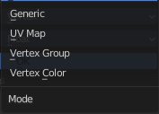
Mode
What kind of attribute the attribute is.
Just the type generic has further settings.

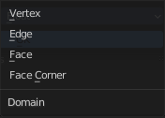
Domain
Just generic. What generic mesh element to affect with the attribute.

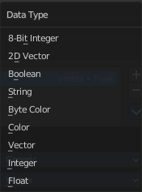
Data Type
Just Generic. What data type to use for the attribute calculation.

Normals panel

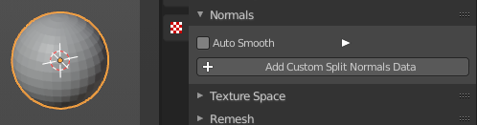
Auto smooth setting. An edge can either be displayed as smooth or sharp. Here you can adjust a threshold value. Below this value an edge will be drawn as sharp. Above this value an edge will be drawn as smooth. This feature requires smooth shading at the mesh.

Autosmooth
Activate Autosmooth.

Autosmooth angle
The threshold angle. This angle is just available when there is no custom normals at the mesh.
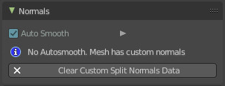
When your mesh has custom normals then the option is greyed out. And a info text appears why it is greyed out. This can already happen when you import a mesh with normals.
Note that you can still tick and untick the checkbox. It just has no effect anymore.

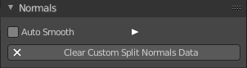
Add / Clear Custom Split Normals Data
Adds a custom split normals data layer, if none exists yet. In case custom normals exists at the mesh, for example because you have marked an edge sharp, then you can remove it here.

Texture Space panel

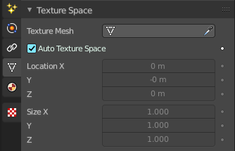
UV mapping can be generated. A procedural brick texture uses generated UV space for example to define the mapping.
In this panel you can adjust settings of the texture space used by generated texture mapping.
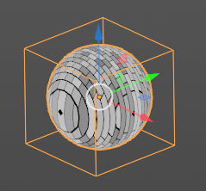




The display of the texture space cage can be activated in the Viewport Display in the Object properties.

Texture Mesh
Use another mesh for texture indices. The vertex of the two objects must be perfectly aligned. Otherwise the UV map will be distorted. Note that, this is only for mesh objects.

Auto Texture Space
Adjusts the active object’s texture space automatically when transforming the object.

Location, Size
Adjust the location and size of the texture space manually if Auto Texture Space is off.


The texture space can also be adjusted in the 3D Viewport. See Object Menu / Transform / Move and Scale Texture Space

Remesh Panel
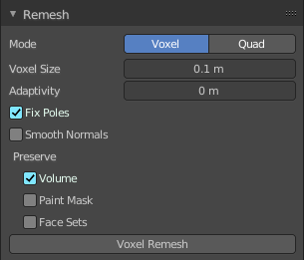
You may create a sculpt mesh that has ways too many polygons. Or too many polygons at one area, and not enough polygons at another area. Remeshing recreates the mesh geometry, with a more uniform topology.
You need to turn off Dyntopo to activate the feature.

Mode
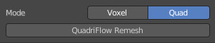
Use Voxel or Quad Remesher. The Quad remesher has no settings. The following settings are all for the voxel remesher.

Voxel Size
Adjust the density of the new created geometry.

Adaptivity
Reduces the final face count by simplifying geometry where detail is not needed. This method uses tris. A value greater than 0 disables the Fix Poles feature.

Fix Poles
Produce less poles and a better topology flow.

Smooth Normals
Smooths the normals of the result.

Preserve

Volume
Tries to preserves the volume of the original mesh.

Paint Mask
Keep existing paint masks at the new mesh.

Face Sets
Keep the current face sets at the new created mesh.

Voxel Remesh / QuadriFlow Remesh
Starts the remesher in the chosen method.

Geometry Data panel

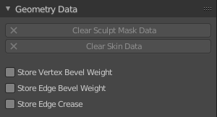
Mesh objects can have different types of custom data attached to them. This data is mostly used internally and can be exported by some exporters like Collada or Alembic.

Clear Sculpt-Mask Data
Removes the sculpting mask data layer. It has no big impact, but this can speed up sculpting if the mask is not longer used.

Clear Skin Data
Used to manage the skin data layer which is used by the Skin Modifier. This operator can be needed in case a Skin modifier is created but no skin data exist.

Store Vertex Bevel Weight
Stores the vertex bevel weight so that it is not overwritten by other operations.

Stores Edge Bevel Weight
Stores the Edge bevel weight so that it is not overwritten by other operations.

Store Edge Crease
Stores the Edge Crease so that it is not overwritten by other operations.

Custom Properties Panel


Here you can define custom properties that can be used for scripting.

Here you might also find custom properties from addons or scripts.

Add
Adds a new property.


Edit
Opens a panel where you can adjust the settings for the custom property.

Remove
Removes the property.

